MINI PROJECT DOCUMENTATION
Submitted By
Name: Dhanuja G
Department: AIML A
College Name: SNS College Of Technology
Year : 4 th year

PROJECT 1: DELL INVENTORY MANAGEMENT SYSTEM
1. Introduction
The Dell Inventory Management System is a web-based application developed to manage Dell product inventory efficiently. The system allows users to add, view, search, update, and delete product details. It is designed to simplify inventory handling while improving understanding of JavaScript arrays and CRUD operations.
2. Objective
The objectives of this project are:
- To manage Dell product details effectively.
- To monitor stock availability.
- To perform CRUD operations efficiently.
- To strengthen JavaScript array handling skills.
3. Technologies Used
Frontend
- HTML5
- CSS3
- JavaScript
Tools
- Visual Studio Code
- GitHub
4. System Features
- Add Product
- View Products
- Search Product
- Update Product
- Delete Product
- Stock Status Management
5. System Architecture
User Interface (HTML/CSS)
↓
JavaScript Logic Layer
↓
Product Inventory Array
↓
Output Display
6. Workflow
- User enters product details.
- Product is added to inventory.
- Inventory list is displayed.
- Search functionality filters products.
- Products can be updated or deleted.
7. Advantages
- Easy inventory management.
- Fast product searching.
- User-friendly interface.
- Improves CRUD operation knowledge.
8. Future Enhancements
- Database integration.
- User authentication.
- Product image upload.
- Low stock alerts.
9. Conclusion
The Dell Inventory Management System provides a simple and efficient platform for inventory tracking and demonstrates practical implementation of JavaScript array operations.

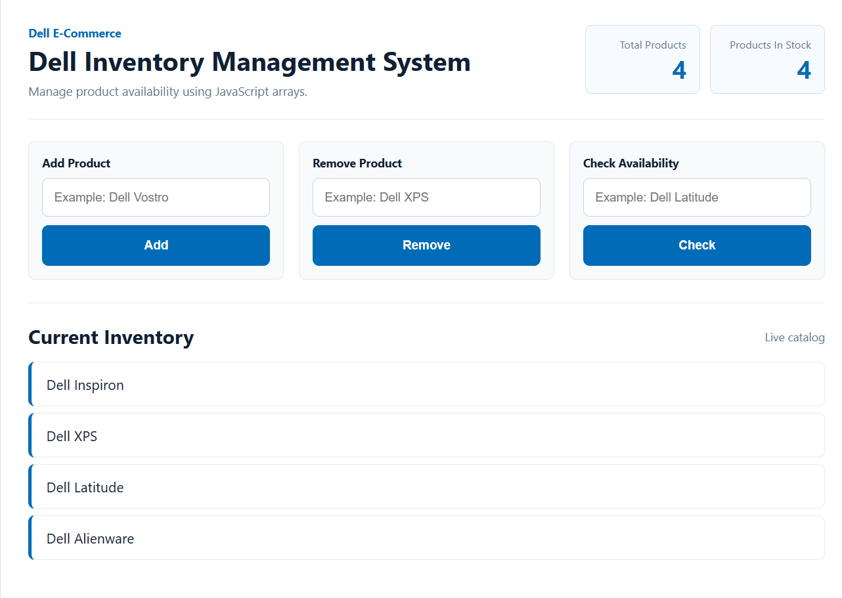

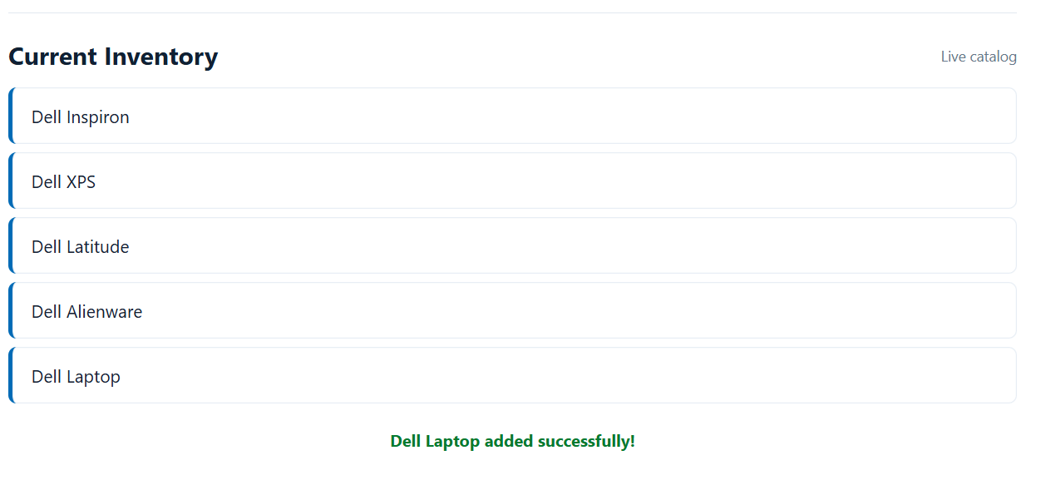
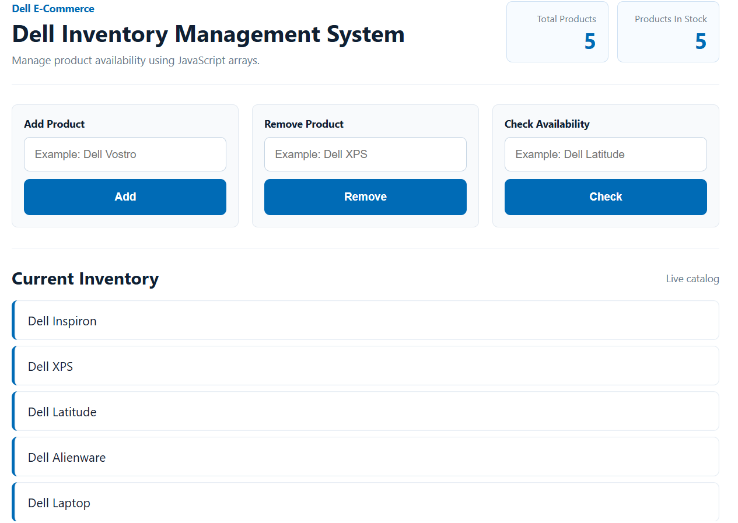
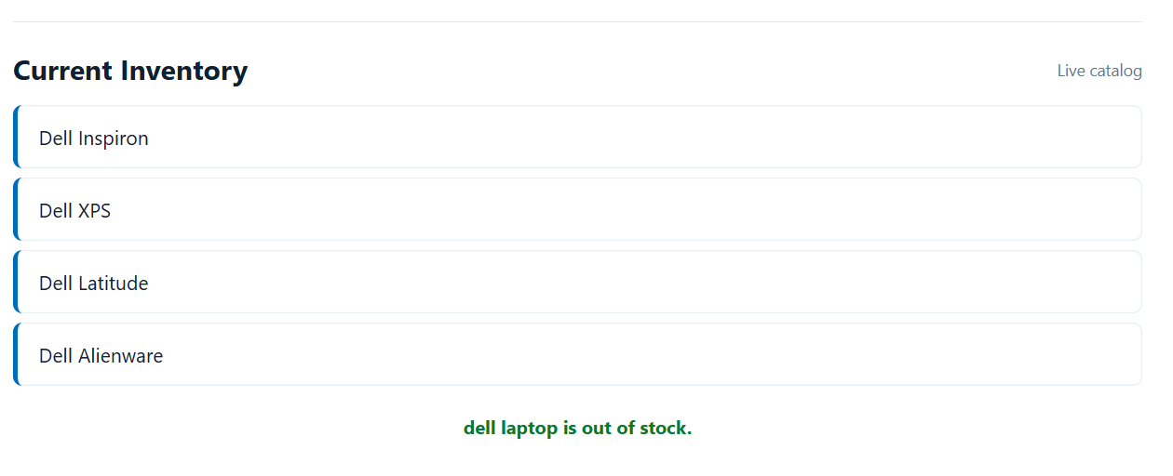
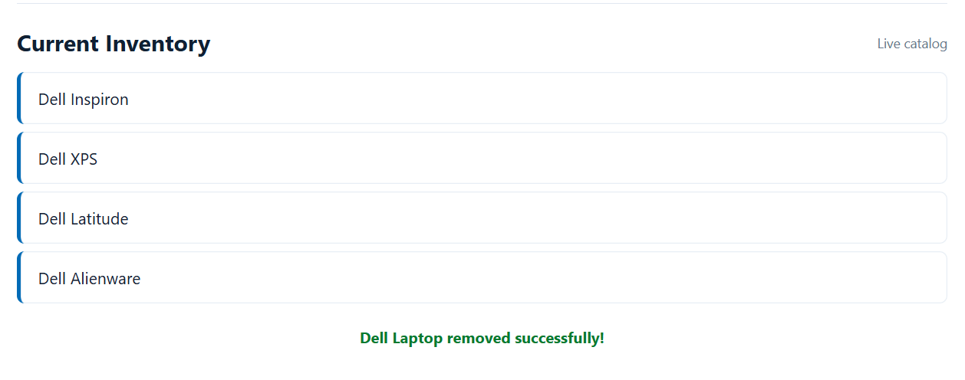

PROJECT 2: ZIGZAG PATTERN GENERATOR
1. Introduction
The Zigzag Pattern Generator is a JavaScript mini-project developed to generate zigzag patterns dynamically based on user input. It focuses on improving logical thinking and strengthening programming fundamentals.
2. Objective
The objectives of this project are:
- To generate zigzag patterns dynamically.
- To improve loop and condition understanding.
- To strengthen problem-solving skills.
3. Technologies Used
Frontend
- HTML5
- CSS3
- JavaScript
Tools
- Visual Studio Code
- GitHub
4. System Features
- Accept user input.
- Generate zigzag patterns dynamically.
- Display pattern output instantly.
- Validate user input.
5. System Architecture
User Interface (HTML/CSS)
↓
JavaScript Logic Engine
↓
Pattern Output Display
6. Workflow
- User enters the number of rows.
- Input is validated.
- JavaScript processes zigzag logic.
- Pattern is displayed.
7. Advantages
- Improves logical thinking.
- Enhances loop understanding.
- Helps in coding practice.
- Easy to modify.
8. Future Enhancements
- Multiple pattern styles.
- Custom symbols.
- Pattern export option.
- Color customization.
9. Conclusion
The Zigzag Pattern Generator successfully demonstrates JavaScript logic implementation for pattern generation and strengthens programming concepts.
